ST10084621

APDS7311 POE Final

BCAD Year 3 – Group 1

Due: 8th October

**Table of Contents**

Screenshots 1

Content 2

Images 3

References 3

# Screenshots

1. Dependency router-dom stored:

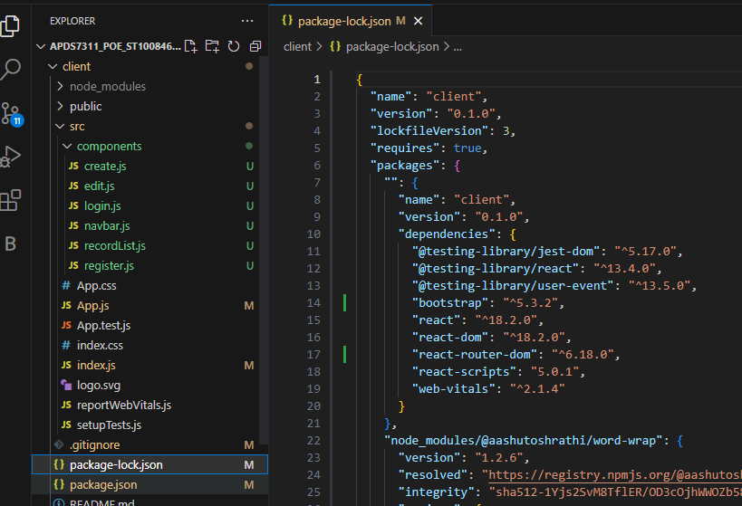

1. Dependency express-brute installed:

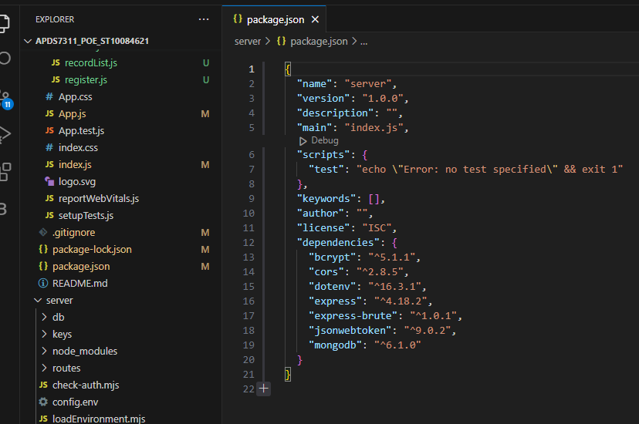

# Content

Google drive link:

<https://drive.google.com/drive/folders/1zNlQ3mXC1Nak02TM7FCd6ou-yVHIUc1Y?usp=sharing>

* Contains demo video

# Images

Images used on website (trendmicro, 2023).

# References

trendmicro, 2023. *trendmicro.* [Online]   
Available at: https://www.trendmicro.com/content/dam/trendmicro/global/en/ciso/thumbnails/22/cybersecurity-plan-2023.png  
[Accessed 8 11 2023].